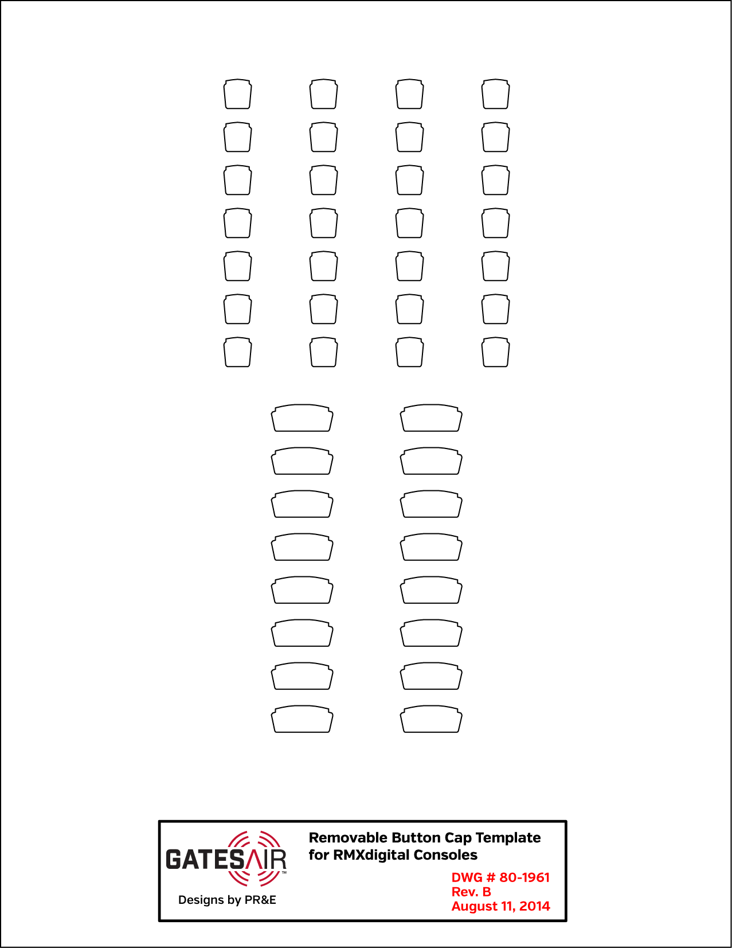
Click on any button text and edit it as desired, making sure your text stays within the label outline. The small square labels use Heading 1 style and the large rectangular buttons use Heading 2 style.
Before printing onto the 80-1961 die cut label sheet, print a test page on plain paper. For best results use manual feed to print both the test page and the die cut sheet. Since this template uses the full page, click Yes to continue if you get a “Do you want to continue to print outside of the margins” warning box.
Hold the test print over the die cut sheet. Use a bright light to verify the test print’s label outlines align with the die cut sheet.
Before printing the 80-1961 die cut sheet:
- Delete the generic text from any labels that are not edited so they can be printed in the future.
- Right-click on the title block. Select Format Picture. Change the Brightness and Contrast to 100% so the title block and label outlines are not shown.
- Click on this text box to select and delete it.

TELCO
1

TELCO 2

mic
1

mic
2

mic
3

mic
4

PLAY
1

PLAY
2

PLAY
3

PLAY
4

CD
1

CD
2

CD
3

CD
4

TELCO
1

TELCO
2

TELCO
3

TELCO
4

TELCO 3

TELCO 4

PHone
2

rmt
1

RMT
2

PRE- DELAY

air mon

air mon

synth air

synth
air

mod mon

net wrk

net wrk

net wrk

TELCO
5

TELCO 6

PHone
1

pre-
delay

pre- delay

air
MON

synth air

MOD MON

MOD
MON

tel rec

TEL rec

tel rec

